**Actual testing strategy**

How to open ‘Batch edit tags’:

1. Open Zotero
2. Click Gear menu 
3. Click ‘Zotero EXTended’ -> ‘Batch edit tags..’

How to open ‘Batch edit tags’:

1. Open Zotero
2. Click Gear menu 
3. Click ‘Zotero EXTended’ -> ‘Custom output styles..’

We put snapshots for some of our test cases for examples.

**For Batch edit tags:**

1. Add no tag.

* Expected result: The message in the textbox for a new tag is changed from ‘eg science’ to

‘You forgot to give a tag!’

* Actual result: the same result as expected result.

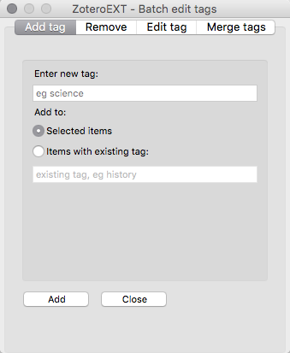 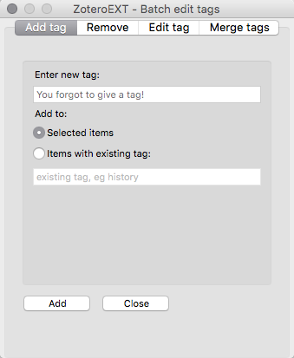

1. Add a single tag to selected items (no items selected)

* Expected result: A pop-up window shows up with ‘No items selected’ message.
* Actual result: the same result as expected result.

1. Add a single tag to selected items (one item selected)

* Expected result: A pop-up window shows up with ‘Tag was successfully added’ message.
* Actual result: the same result as expected result.

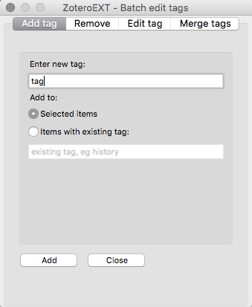 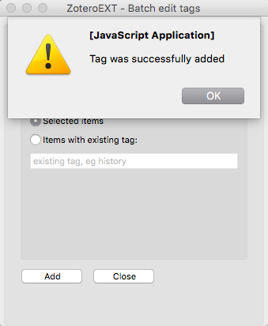

1. Add a single tag to selected items (many items selected)

* Expected result: A pop-up window shows up with ‘Tag was successfully added’ message.
* Actual result: the same result as expected result.

1. Add a single tag to items with existing tag. (no existing tag)

* Expected result: A pop-up window shows up with ‘No items selected’ message.
* Actual result: the same result as expected result.

1. Add a single tag to items with existing tag. (existing tag)

* Expected result: A pop-up window shows up with ‘Tag was successfully added’ message.
* Actual result: the same result as expected result.

1. Add a single tag that already exists.

* Expected result: A pop-up window shows up with ‘Tag was successfully added’ message.

But it does not add another tag with the same name.

* Actual result: the same result as expected result.

1. Remove no items.

* Expected result: It does nothing.
* Actual result: the same result as expected result.

1. Remove a single tag by checking a box.

* Expected result: It removes the tag that is checked.
* Actual result: the same result as expected result.

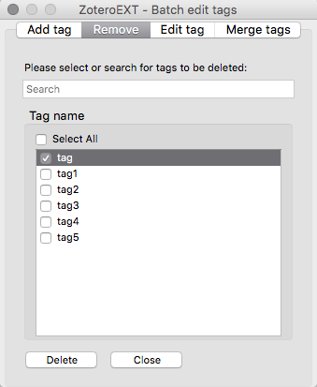 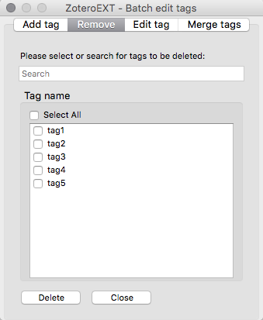

1. Remove several tags by checking boxes.

* Expected result: It removes the tags that are checked.
* Actual result: the same result as expected result.

1. Remove all tags by checking ‘Select All’ box.

* Expected result: It removes all the tags.
* Actual result: the same result as expected result.

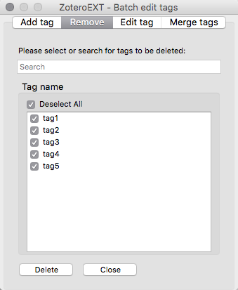 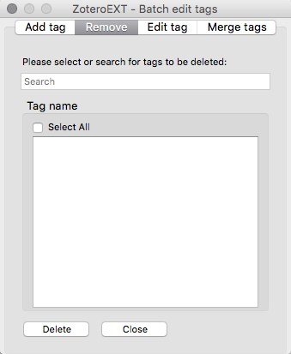

1. Search a tag using search box, and remove a single tag that is searched.

* Expected result: It removes the tag that is searched and checked.
* Actual result: the same result as expected result.

1. Search a tag using search box, and remove several tags that are searched.

* Expected result: It removes the tags that are searched and checked.
* Actual result: the same result as expected result.

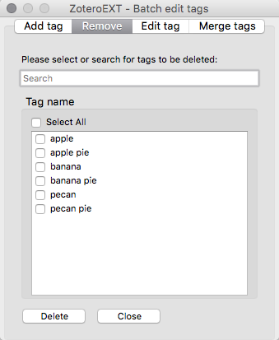 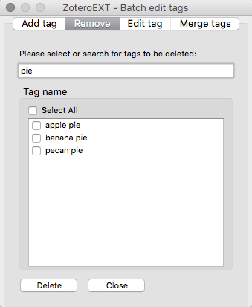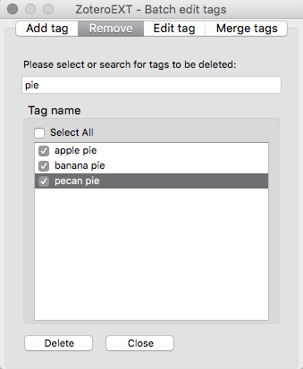 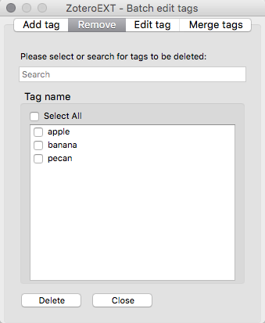

1. Search a tag using search box, and remove all tags that are searched

using ‘Select All’.

* Expected result: It removes all the tags that are searched and selected.
* Actual result: the same result as expected result.

1. Edit no tags.

* Expected result: A pop-up window shows up with ‘0 tags successfully renamed’

message.

* Actual result: the same result as expected result.

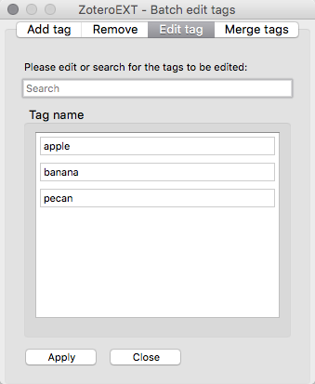 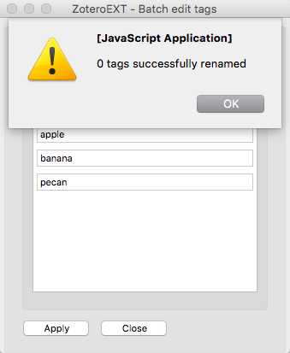

1. Edit a single tag from the list.

* Expected result: A pop-up window shows up with ‘1 tags successfully renamed’

message.

* Actual result: the same result as expected result.

1. Edit several tags from the list.

* Expected result: A pop-up window shows up with ‘n tags successfully renamed’

message. (where n is the number of the tags that are renamed)

* Actual result: the same result as expected result.

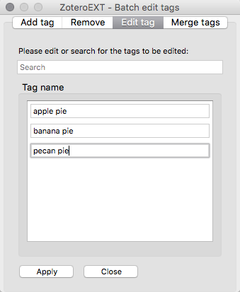 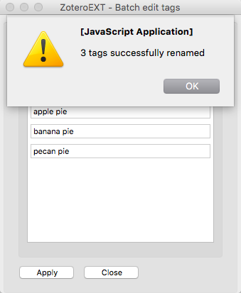

1. Search a tag and edit a single tag that is searched.

* Expected result: A pop-up window shows up with ‘1 tags successfully renamed’

message.

* Actual result: the same result as expected result.

1. Search a tag and edit several tags that are searched.

* Expected result: A pop-up window shows up with ‘n tags successfully renamed’

message. (where n is the number of tags that are renamed)

* Actual result: the same result as expected result.

1. Merge no tags.

* Expected result: It does nothing.
* Actual result: the same result as expected result.

1. Merge two tags into an existing tag.

* Expected result: It merges two tags into an existing tag.
* Actual result: the same result as expected result.

1. Merge two tags into a new tag.

* Expected result: It merge two tags into the new tag.
* Actual result: the same result as expected result.

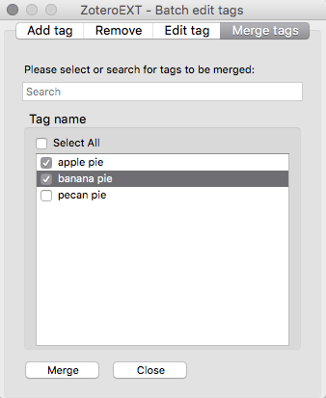 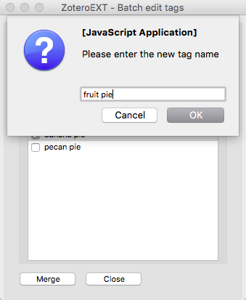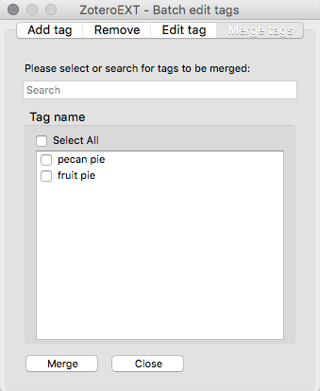

1. Merge several tags into a new tag.

* Expected result: It merges several tags into the new tag.
* Actual result: the same result as expected result.

1. Merge several tags into an existing tag.

* Expected result: It merges several tags into the existing tag.
* Actual result: the same result as expected result.

1. Search a tag and merge two tags into a new tag.

* Expected result: It merges the tags that are searched into the new tag.
* Actual result: the same result as expected result.

1. Search a tag and merge two tags into an existing tag.

* Expected result: It merges the tags that are searched into the existing tag.
* Actual result: the same result as expected result.

1. Search a tag and merge all searched tags into a new tag by checking ‘Select All’

* Expected result: It merges all the tags that are searched into the new tag.
* Actual result: the same result as expected result.

1. Search a tag and merge all searched tags into an existing tag

by checking ‘Select All’ box.

* Expected result: It merges all the tags that are searched into the existing tag.
* Actual result: the same result as expected result.

1. Search a tag and merge several tags into a new tag.

* Expected result: It merges the tags that are searched into the new tag.
* Actual result: the same result as expected result.

1. Search a tag and merge several tags into an existing tag.

* Expected result: It merges the tags that are searched into the existing tag.
* Actual result: the same result as expected result.

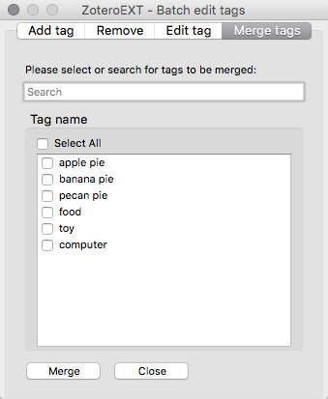 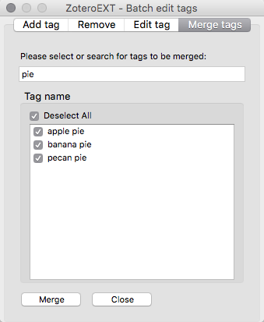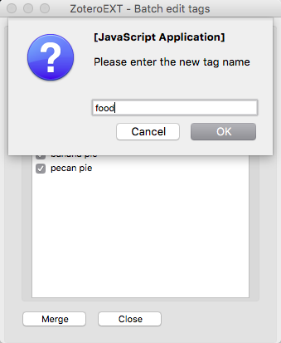 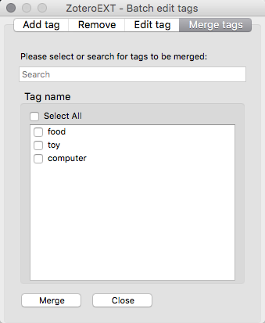

**For Custom output styles:**

1. Click ‘About’, ‘Search by name’, ‘Search by example’, ‘Visual editor’, or ‘Code

editor’ to check those tabs are working.

* Expected result: It shows different pages by clicking different tabs.
* Actual result: the same result as expected result.

1. Search a style from ‘Search by example’.

* Expected result: It shows the first example style.
* Actual result: the same result as expected result.

1. Click ‘Next’ to view the next example from ‘Search by example’.

* Expected result: It shows the next example style.
* Actual result: the same result as expected result.

1. Click ‘Previous’ to view the previous example from ‘Search by example’.

* Expected result: It shows the previous example style.
* Actual result: the same result as expected result.

1. Search a style (for example, ‘APA’) from ‘About’ or ‘Search by name’.

* Expected result: It shows ‘APA’ styles.
* Actual result: the same result as expected result.

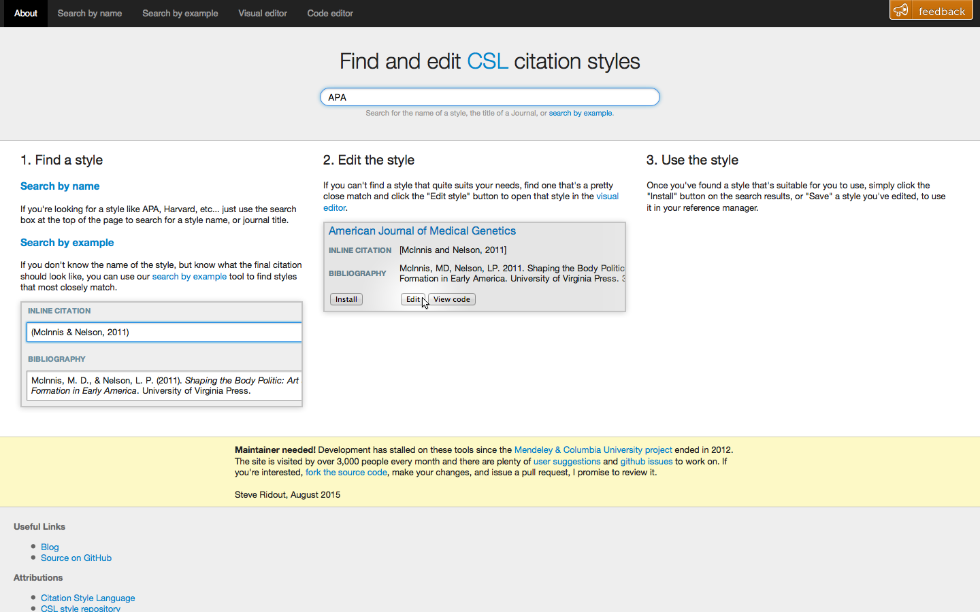

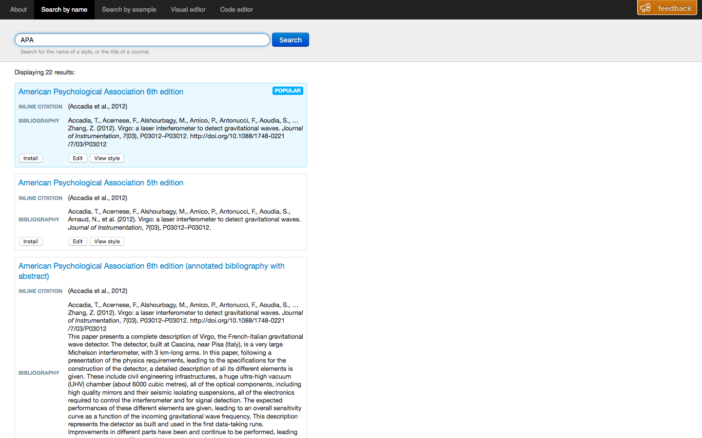

1. Click the title of the style to see the detail (after search a style).

* Expected result: It shows detail of the style.
* Actual result: the same result as expected result.

1. Click ‘View style’ button to see the detail (after search a style).

* Expected result: It shows detail of the style.
* Actual result: the same result as expected result.

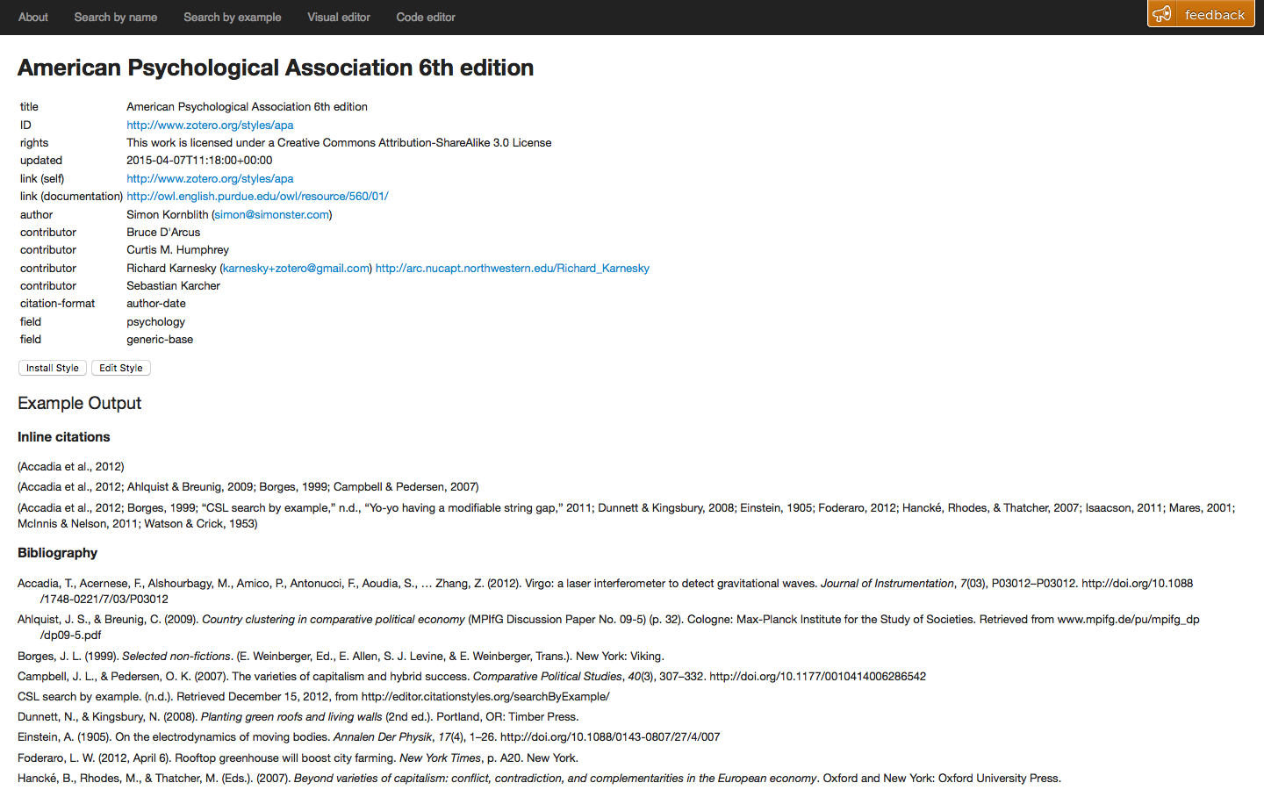

1. Install a new style by clicking ‘Install’ button (after search a style).

* Expected result: It installs the new style.
* Actual result: the same result as expected result.

1. Install an existing style by clicking ‘Install’ button (after search a style).

* Expected result: It updates/replace the existing style.
* Actual result: the same result as expected result.

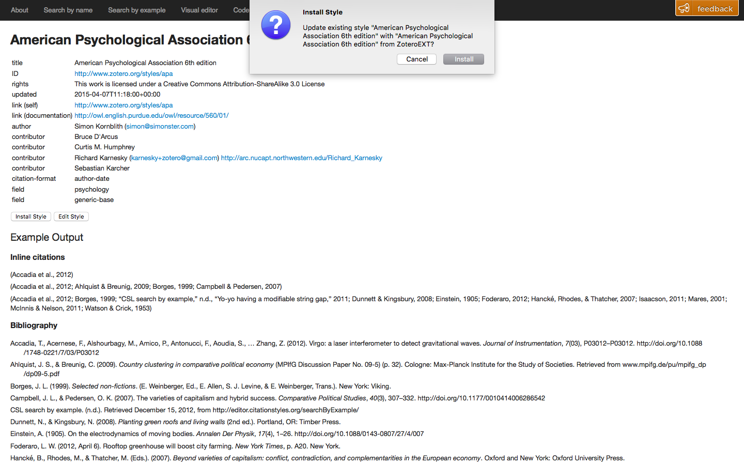

1. Edit a style from ‘Code editor’.

* Expected result: It shows the style as codes.
* Actual result: the same result as expected result.

1. After search a style, edit a style by clicking ‘Edit’ button

(It will go to Visual editor).

* Expected result: It shows ‘Visual editor’
* Actual result: the same result as expected result.

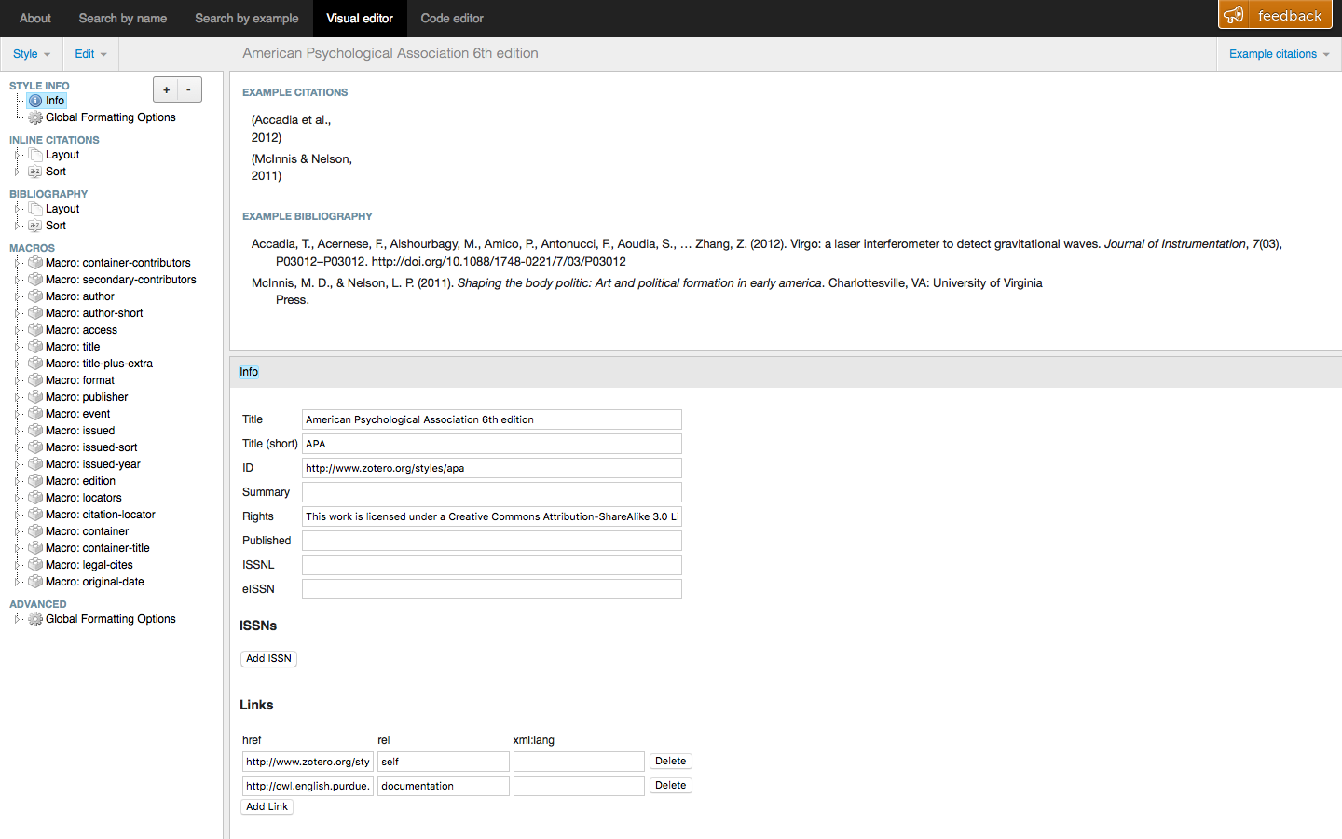

1. Edit a style and undo the change by clicking ‘Edit’ -> ‘Undo’ from ‘Visual editor’.

* Expected result: It undoes the change.
* Actual result: the same result as expected result.

1. Redo the change by clicking ‘Edit’ -> ‘Redo’ from ‘Visual editor’.

* Expected result: It redoes the change.
* Actual result: the same result as expected result.

1. Make a new style by clicking ‘Style’ -> ‘New Style’ from Visual editor.

* Expected result: It makes a new style.
* Actual result: the same result as expected result.

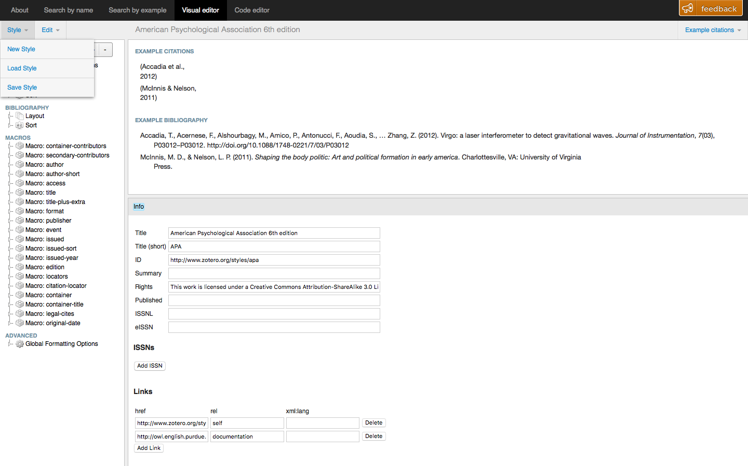

1. Save a style by clicking ‘Style’ -> ‘Save Style’ from Visual editor.

* Expected result: It saves the style.
* Actual result: the same result as expected result.

1. Load a style by clicking ‘Style’ -> ‘Load Style’ from Visual editor.

* Expected result: It loads the style.
* Actual result: the same result as expected result.

**An “ideal” testing strategy**

If we had the time and the tools, In addition to the acceptance tests provided we would have liked to make use of unit testing for our backend functions, primarily for batch editing tags.